**BL 1110 Lab 1a: Microscope use (15 pts)**

Due the week of 09/13 (submit on Canvas)

**Learning Objectives:**

In this lab you will become familiar with the use of dissecting and compound microscopes. Specifically, by the end of the lab you should:

* Know the difference between compound and dissecting microscopes
* Know how to handle and work with compound and dissecting microscopes
* Be able to label and define the function of the various parts and functions of microscopes
* Understand what magnification, the relative size of images, field size, field of view (FOV), real image, and apparent image refer to
* Be able to calculate magnification, the relative size of images, field size, and FOV

**Introduction:**

Because the human eye can only distinguish objects that are approximately 0.1 mm in size. we need to magnify many organisms or parts of them to accurately observe them.

**Compound vs. Dissecting Microscopes**

The main difference between the compound and dissecting microscope is that a compound microscope is used to view *very* small objects (such as contents of cells ) using its capability of higher magnification. A dissecting microscope is used to magnify larger objects or specimens by use of lower magnification. You have more space to manipulate the object being viewed, hence, dissecting microscopes are often used to dissect certain specimens in biology. **We will be working with compound microscopes more frequently, but you will see and work with a dissecting scope on occasion.**

**Magnification and Field Diameter**

To begin, you must first plug in the microscope and switch it on. When switching on the microscope, the light needed to view your specimen does not automatically turn on, therefore, you must also make sure the light is turned after turning on the microscope. When you turn on the light, see how a beam passes through the condenser and specimen.

The specimen can be seen through an **objective** that magnifies the image of the specimen. **Microscopes generally have 3-4 objectives (4X, 10X, 40X, 100X)**. These are housed on the stem and can be rotated so that the correct one can be used for observation. The magnified image is then transmitted through the **oculars**, the pieces that you look through. Oculars have lenses that magnify the image of the specimen by 10x. When you observe the image of your specimen through a microscope, it has been magnified twice – first with the objective and then with the ocular. For example, if you view a specimen under the objective lense 40X, then the magnification is 400X (40X x 10X magnification = 400X magnification).

**Part 1: Calculating magnification.**

Total magnification is calculated by multiplying the magnification value of your ocular lens by the objective lens you are using. **Note that the ocular lens always has a magnification of 10X.**

*Total magnification = objective lens x ocular lens*

*Example*: What is the total magnification of a pollen grain being observed under an objective lens of 4X?

*Answer:*

Objective lens = 4X

Ocular lens = 10X

Total magnification = 4X x 10X = 400X

1. What is the total magnification of a cell being observed under the following objective lenses? **(1pt)**
   1. 10X =     __________
   2. 45X =     __________

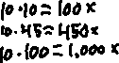

* 1. 100X =    __________

**Part 2: Calculating Field Diameter.**

The distance across the circle that you see when you look in the microscope is called the field diameter. We can calculate the diameter of your field of view with a simple algebraic equation if the field diameter at the lowest magnification is known.

Change your objective lens to the lowest magnification (4X). **In order to estimate the field diameter, examine a slide of 1mm graph paper at low power. Count how many squares fit across the field (diameter).** You will use this number to calculate the field diameter of the other objectives so write it down below:

1. What is the field diameter you counted at 4X? _________mm **(1 pt)**



To calculate the field of view at a stronger magnification, you must use the following equation:



where “*Magnification A*” is the *total* magnification of the lowest power you viewed the graph paper, “*Magnification B*” is the *total* magnification of the objective lens you are trying to calculate field diameter for, and “*Field Diameter A (mm)*” is the field of view you counted using graph paper at 4x in millimeters.

*Example:* You measured the FD at low power (4X) to be 4.5mm. Calculate the FD at medium power (10X).

*Answer:*

Magnification A = 40X

Magnification B = 100X

Field diameter A = 4.5mm

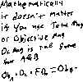

1. What is the field of view at the following magnifications? *Hint*: remember to use total magnification. Use the field diameter you counted in question 2 to help you answer. **(1 pt)**



* 1. 10X =     __________
  2. 45X =     __________



* 1. 100X =    __________



1. Fill out this table: **(1 pt)**



|  |  |  |  |  |
| --- | --- | --- | --- | --- |
| **Power** | **Objective Mag.** | **Ocular Mag.** | **Total Mag.** | **Field Diameter** |
| **Low** |  |  |  |  |
| **Medium** |  |  |  |  |
| **High** |  |  |  |  |

**Part 3: Using the Microscope**

The image that you see through the microscope lens is called the **apparent image**, whereas what you see when viewing the specimen with your naked eye is called the **real image**.

To focus the microscope, there are two adjustment knobs, the course (large) and fine (small) adjustments. **Always begin looking at your specimen using the smallest objective lens (4X), or the lowest magnification.** Begin focusing on the specimen by using the coarse adjustment knob. After you have the specimen in focus, then switch to using the fine adjustment knob to get a sharper focus. **When using all other objectives, use ONLY the fine focus adjustment knob to prevent damage to scopes or slides!**

**Part 1: Letter ‘e’ Slide.** Obtain a “letter ‘e’ slide”. Look at it under the microscope and note how it changes orientation as you move it around the stage. Answer the following questions:

1. Move the slide towards and away from you, and from side to side. In what direction does the letter appear to be moving in relation to the way you are moving the slide? **(1 pt)**



1. What is responsible for these reversals in orientation and movement of objects seen through a microscope? **(1 pt)**



**Part 2: Overlapping Threads Slide.** Obtain a prepared slide with three different overlapping colored threads. Answer the following questions:

1. Look at the slide under the 4x magnification and note the working distance (distance between the objective lens and your microscope slide). Now rotate the nosepiece so you are looking at the slide through the 10x magnification. How did the working distance and magnification change? **(1 pt)**



1. Using 10x magnification, locate a portion of your slide where all three threads overlap. Use the fine-adjust knob to focus up and down through the overlapping threads. Why do some threads appear to be in focus (clear) while others appear blurry as you use the fine-adjust? **(1 pt)**



1. Now look at the slide under 40x. What is happening to your field of view (the area you can see through the microscope) as you changed from 10x to 40x?What is the relationship between field of view and magnification? **(1 pt)**



**Part 3: House Fly Head.** Obtain a prepared slide of the common housefly, *Musca domestica*. Answer the following questions:

1. Focus on what you think is the front of the head at 40X total magnification. Estimate the width of the eye in millimeters using the information from your earlier field of view (FOV) calculation. **(1 pt)**



1. Estimate the width of the entire head (left to right at 40X total magnification) – again use the information from your FOV calculation. **(1 pt)**



1. Now focus on the eye at 100X total magnification. Measure the width and length of the eye at this magnification using your FOV calculations. Are these measurements like the ones you took at 40X total magnification? Why or why not? **(1 pt)**



1. Flies and many other insects have compound eyes, which are made up of individual units called ommatidium (plural ommatidia). Describe the difference in detail that you see at 40X total magnification versus 100X total magnification. Under which magnification do you see detail? **(1 pt)**



**Part 4: Drawing and Labeling Images.**

When sketching specimens, always include the **(1) total magnification, (2) size of specimen in millimeters (mm) or micrometers (um), and (3) a label of the whole specimen and for individual parts observed.** For best resolution of structures, sketches should be made while viewing slides at the 40X objective – but remember to begin with the lowest objective and work your way up.

**Making wet mounts of live specimens:**

Members of the Kingdom Protista (Protozoans) are unicellular (single-celled) organisms. They are the simplest of the eukaryotic organisms. Although they are unicellular, some species may live in aggregates or colonies (e.g., *Volvox*), where each cell derives some benefit from the association but is largely independent. *Volvox* is a green colonial organism. The cells are not specialized for different functions, as would be the case in true multicellular organisms. Most of the Protists are aquatic, but some live in the digestive tracts of other organisms.

1. Obtain a depression slide, a coverslip, and some Vaseline.
2. With a cotton-tip swab “paint” Vaseline around the circle of the depression slide. This will prevent the coverslip from crushing the *Volvox*. These organisms are large enough that using a cover slip on some slides may smash the organisms leaving only pieces to observe.
3. Add a few drops of the water containing the *Volvox* and add the cover slip.
4. First, observe the slide under low power (40X). Once you are able to visualize them under low power, observe them under medium power (100x).

14. Make a sketch of a *Volvox* and label the internal organelles that you can identify (daughter colony, flagellated cells, jelly matrix). Remember to correctly label the magnification. **(1 pt)**

15. Determine the approximate size of the specimen in millimeters and micrometers at 100X total magnification using your FOV calculations. **(1 pt)**



Total Magnification: _______________________________

Field Diameter: ________________________,



Fraction of FD that *Volvox* fills: ______________________



Approx. Size: ___________________mm _________________________um



Compound/Light Microscope

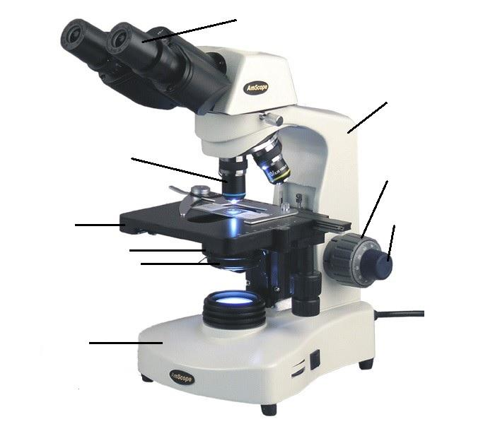



Stereoscopic/Dissecting Microscope

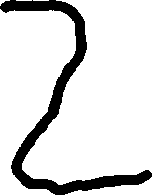

Stereoscopic/Dissecting Microscope

